Missing Child Identification System using Deep Learning and Multiclass SVM

In this paper author is describing concept to identify missing children by using Deep Learning and Multiclass SVM classifier and to implement this project author has used below modules

1. Using public dataset of missing children’s called FGNET is used to train deep learning CNN prediction model. After training model whenever public upload any suspected child image then this model will check in trained model to detect whether this child is in missing database or not. This detected result will store in database and whenever want official persons will login and see that detection result.
2. SVM Multiclass classifier use to extract face features from images based on age and other facial features and then this detected face will input to CNN model to predict whether this face child exists in image database or not.

First we used below dataset to train deep learning CNN model

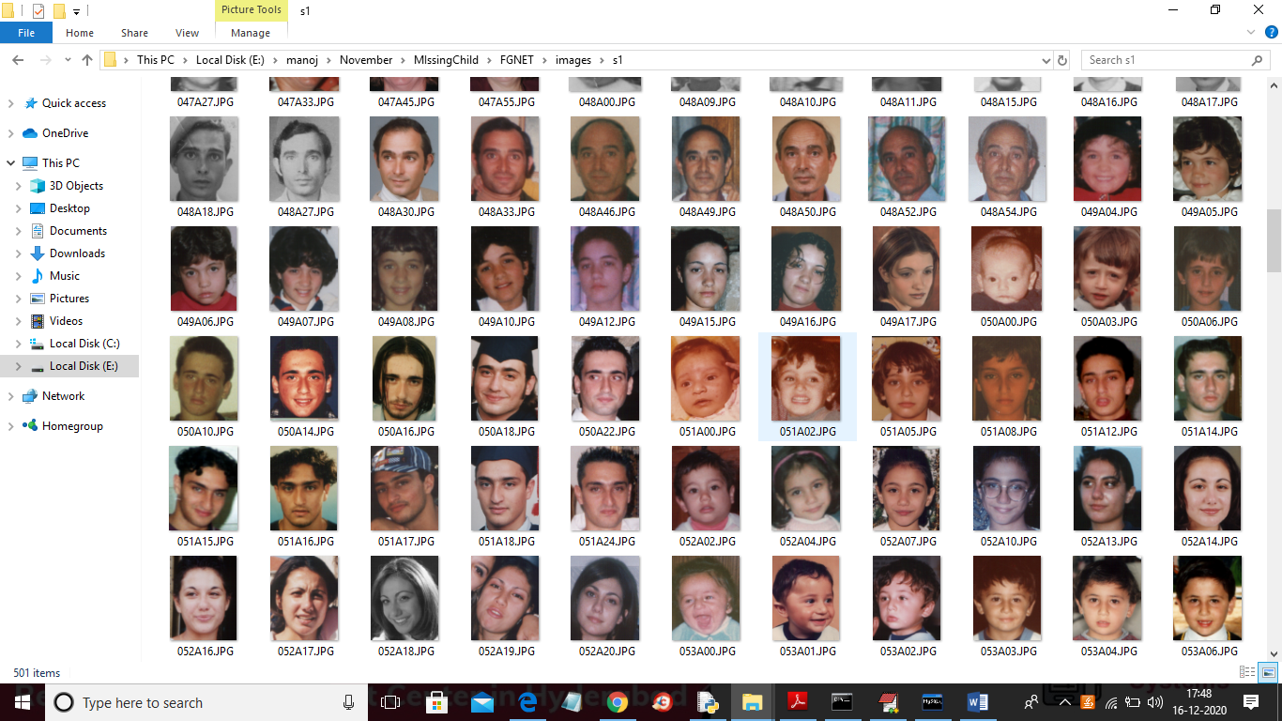

To run project follow below steps

1) First create database in MYSQL by copying content from ‘DB.txt’ file and paste in MYQL

2) Install python, DJANGO and MYSQL software

3) Create ‘Python’ folder in C directory and put ‘MissingChilds’ folder in it

4) start DJANGO server and run in browser to get first page

SCREEN SHOTS

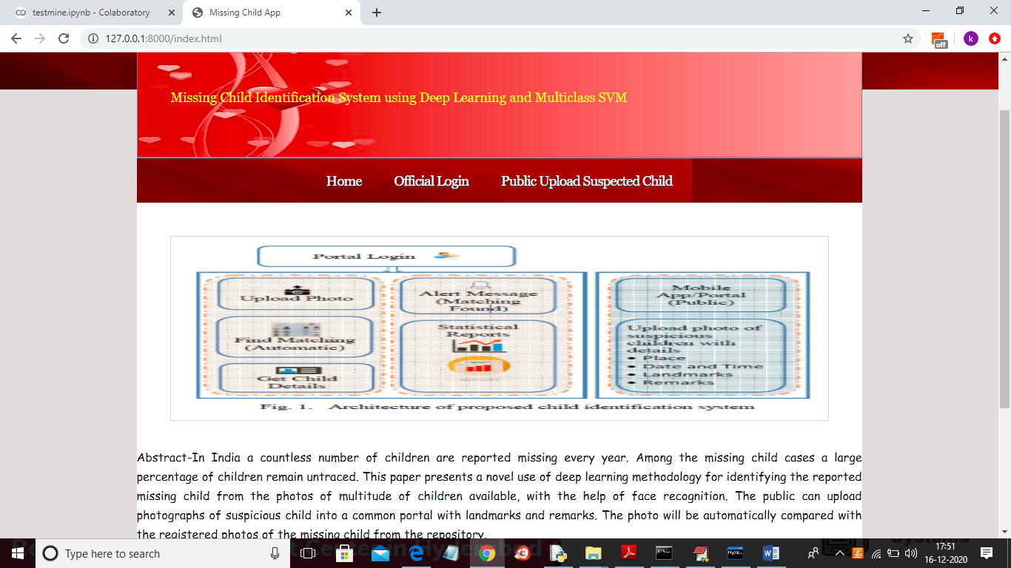

In above screen public can click on ‘Public Upload Suspected Child’ link to get below page and to add missing child details

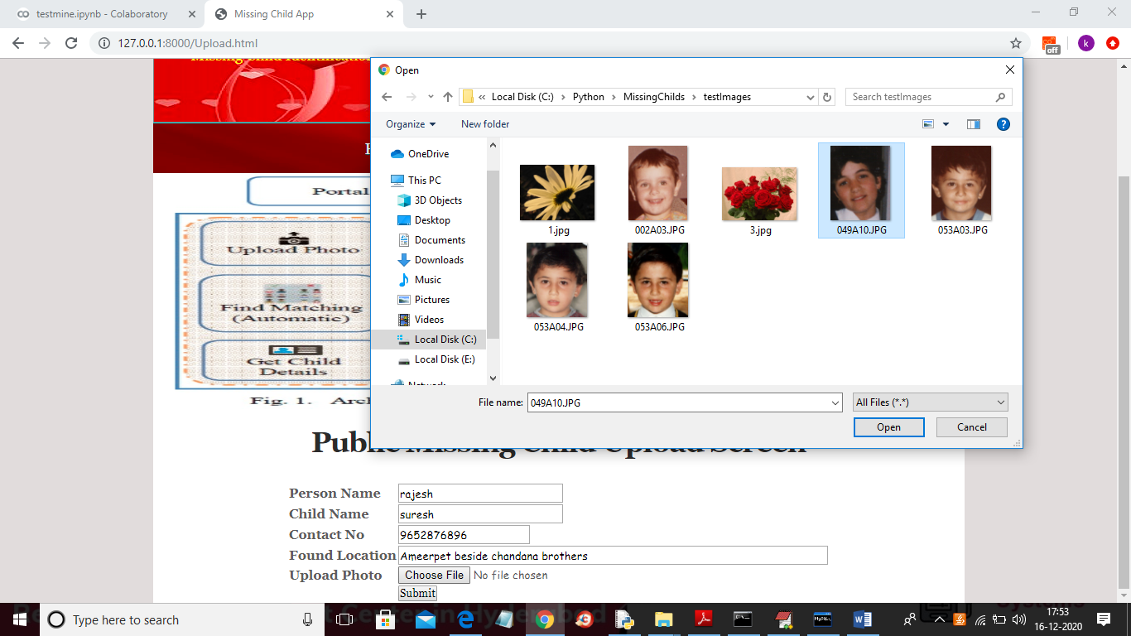

In above screen public will enter suspected child details and then upload photo and then click on ‘Submit’ button and to get below result

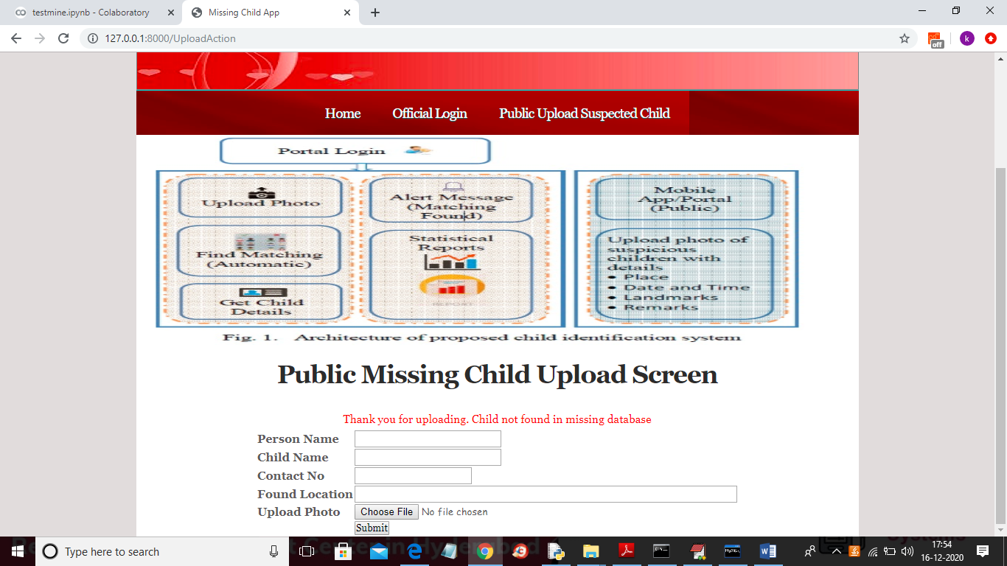

In above screen we can see child not found in missing DB and we can try with other image

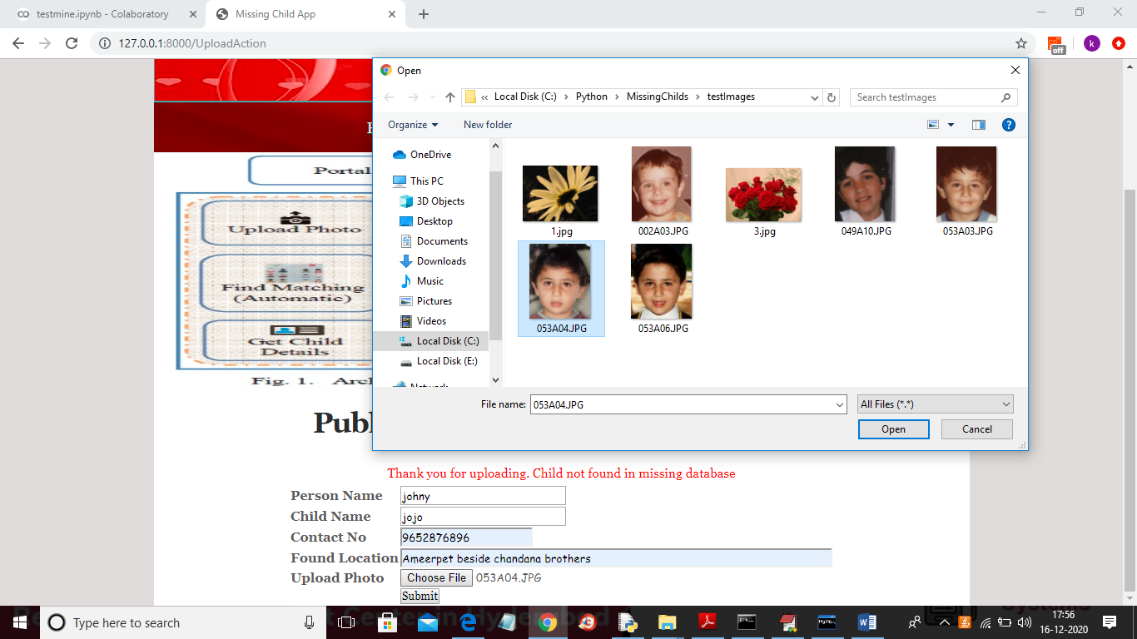

And below is the result for new above child details

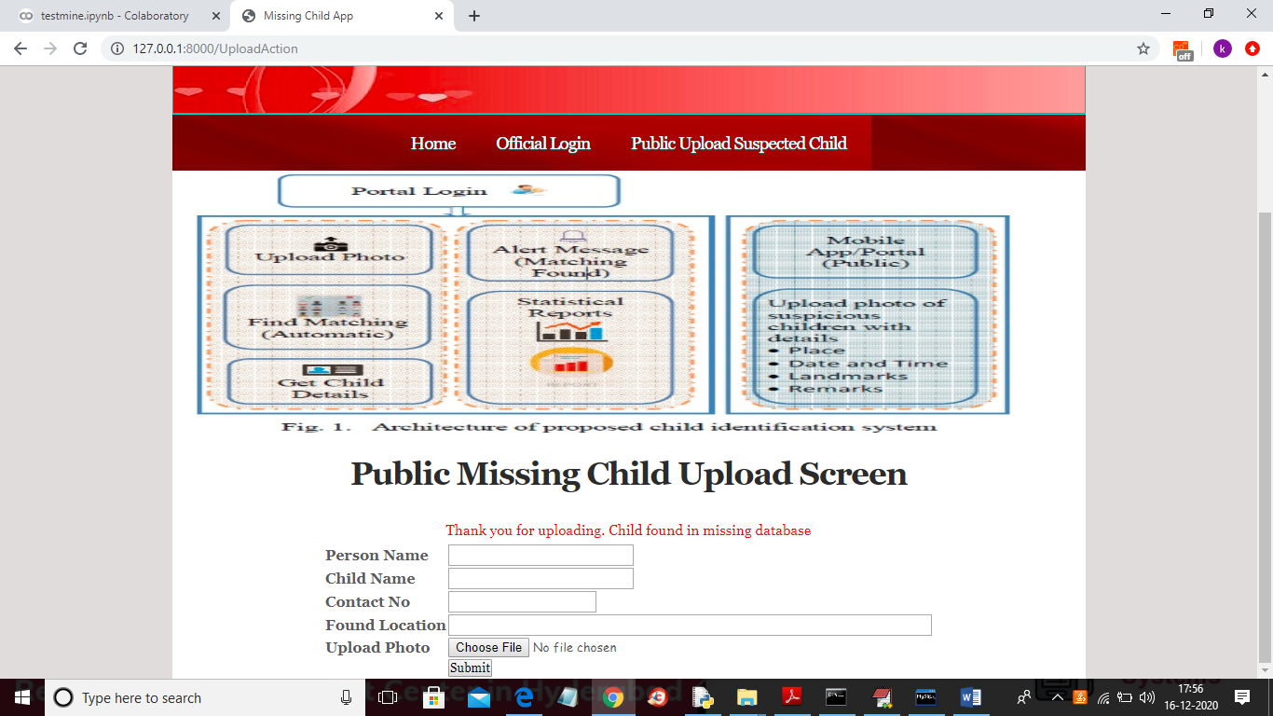

In above screen uploaded child found in database and now click on ‘Official Login’ link to get below login screen

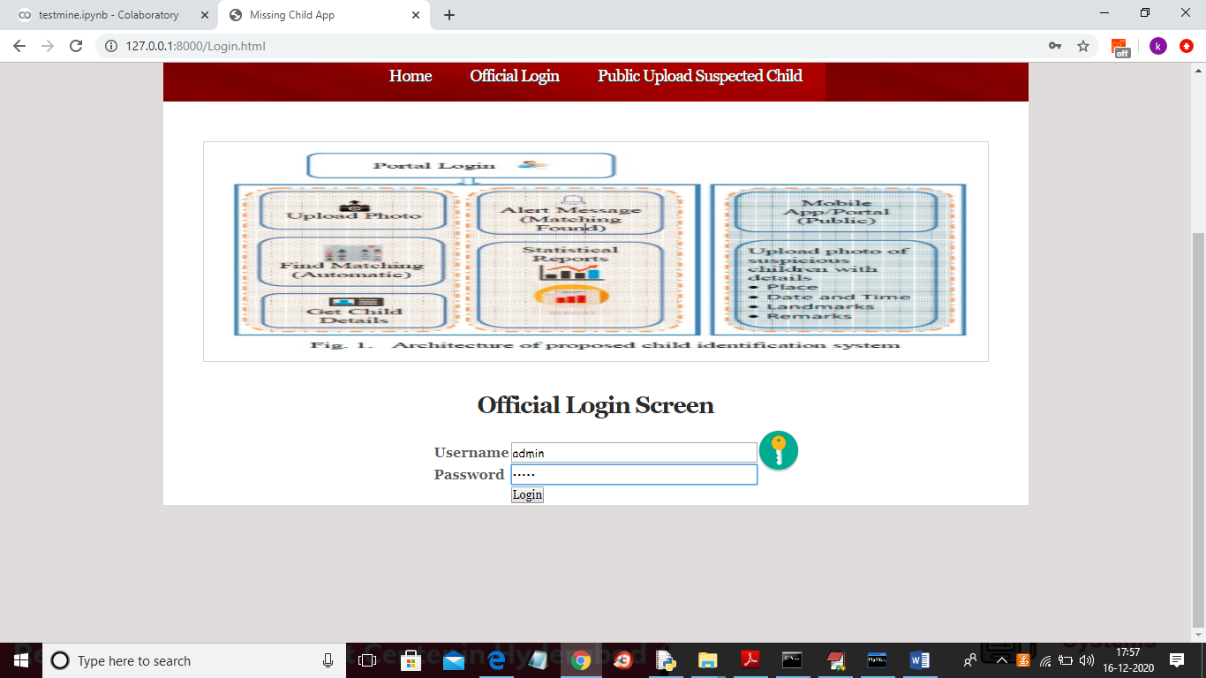

In above screen admin can login by entering username and password as ‘admin’ and ‘admin’ and after clicking on ‘Login’ button will get below screen

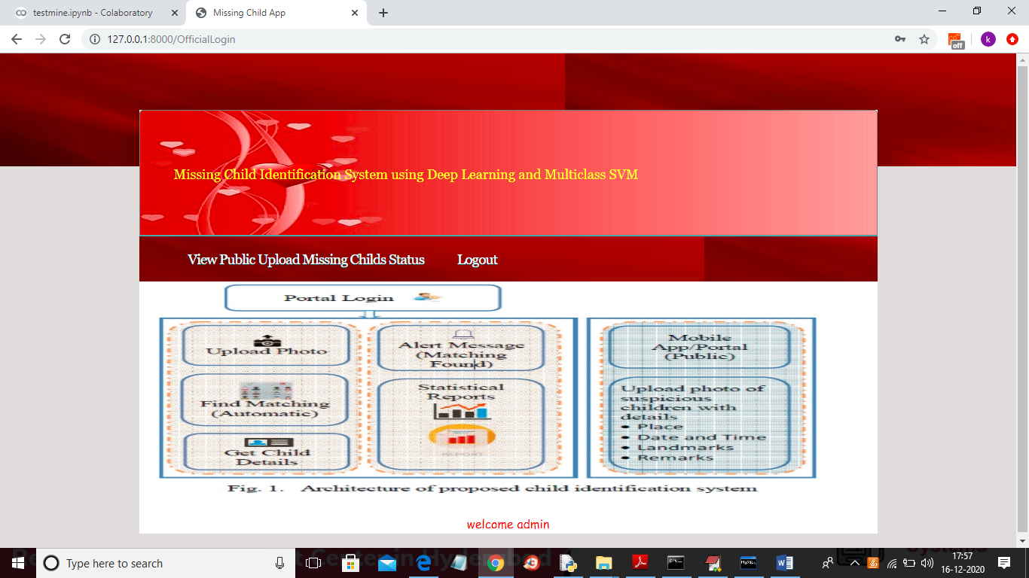

In above screen official can click on ‘View Public Upload Missing Childs Status’ link to view all uploads and its result done by public

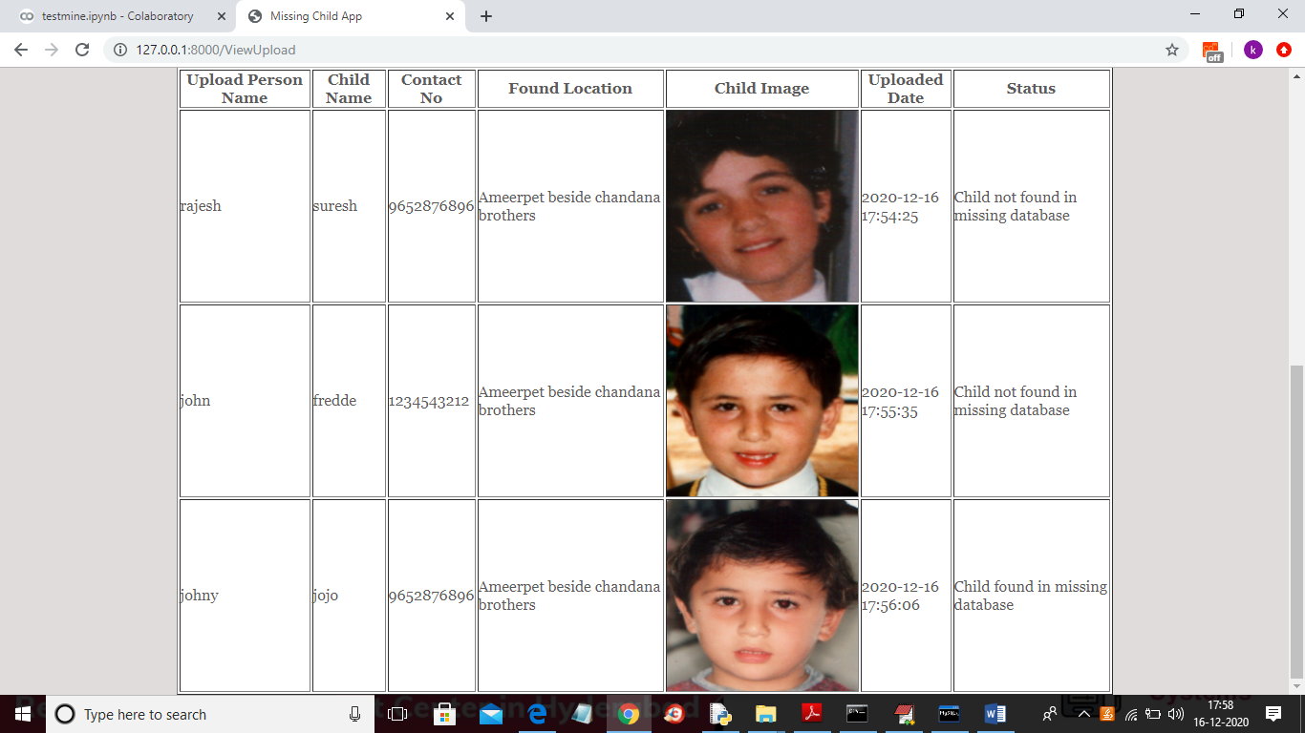

In above screen officials can see all details and then take action to find that child